Embedded Controller Win 7 🡺 Win 10 Upgrade Information Sheet

**Contact Name**: **Company**:

**Contact Phone**: **E-mail**:

**Job/Facility**: **# of Controllers to Upgrade**:

**\*Note: IED1100/1200 or 32-bit Series controllers cannot be updated to Windows 10**

**If your license is EXPIRED, please contact your sales associate first as this will speed up the process.**

**Info we need will also include the VBK file (data backup), LFX file (license) and the GCB file (messages backup) or c:/message folder zipped. Contact:** [**licensing@atlasied.com**](mailto:licensing@atlasied.com) **or your salesperson for any questions, all three files are needed to begin.**

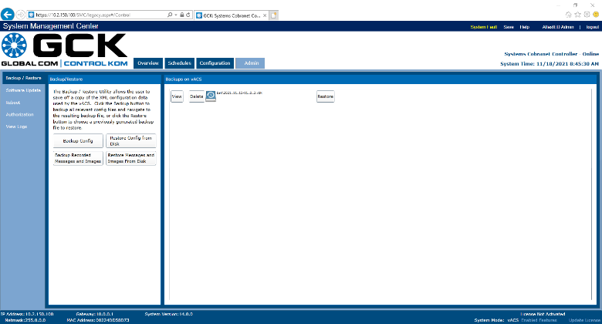 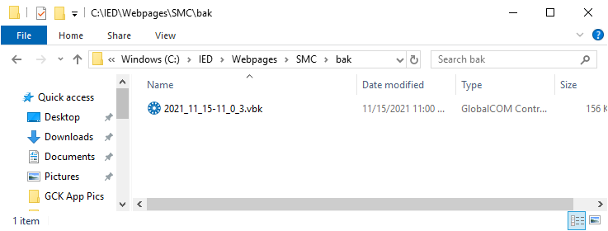 **VBK/GCB**



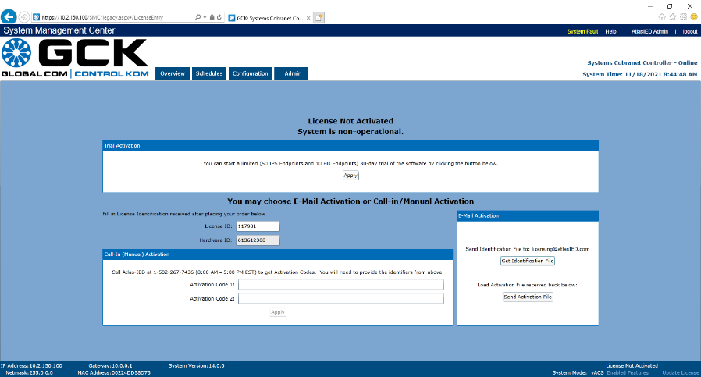 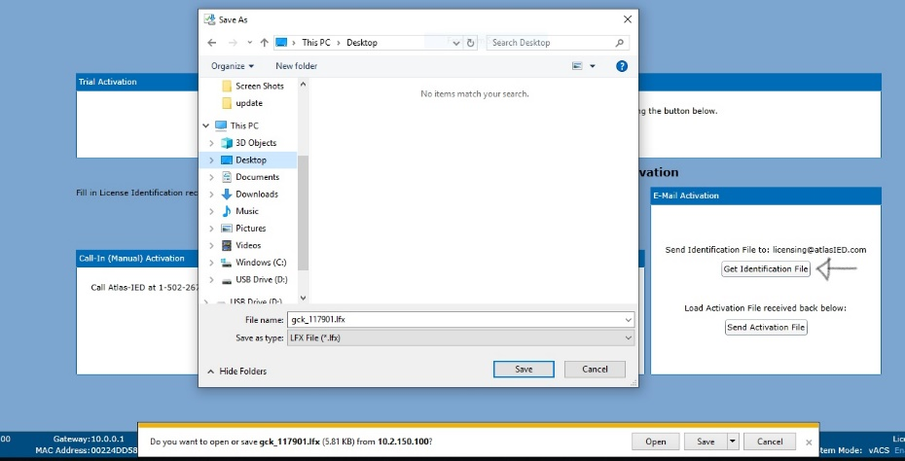 **LFX**

1/2

|  |  |  |  |  |  |
| --- | --- | --- | --- | --- | --- |
| **Information** | **Controller #1** | **Controller #2** | **Controller #3** | **Controller #4** | **Controller #5** |
| **IP Address:** |  |  |  |  |  |
| **HW Type** | □ IP108 □ IP116  □Cobranet  □Dante | □ IP108 □ IP116  □Cobranet  □Dante | □ IP108 □ IP116  □Cobranet  □Dante | □ IP108 □ IP116  □Cobranet  □Dante | □ IP108 □ IP116  □Cobranet  □Dante |
| **Primary or Lifeline?** | □ Pri □ LLne | □ Pri □ LLne | □ Pri □ LLne | □ Pri □ LLne | □ Pri □ LLne |
| **Serial #**: |  |  |  |  |  |
| **GCK License Expiration Date** |  |  |  |  |  |
| **# HD Endpoints** |  |  |  |  |  |
| **# IP Endpoints** |  |  |  |  |  |
| **SAFE Feature Installed?** | □ Yes □ No | □ Yes □ No | □ Yes □ No | □ Yes □ No | □ Yes □ No |
| **FAS Message Library Installed?** | □ Yes □ No | □ Yes □ No | □ Yes □ No | □ Yes □ No | □ Yes □ No |
| **FAS Language(s)** |  |  |  |  |  |
| **Ambient Noise/EQ being Used? *if YES Send C:IED/services/vACS/Ambient Folder** | □ Yes □ No | □ Yes □ No | □ Yes □ No | □ Yes □ No | □ Yes □ No |
| **Visual Paging Used?** | □ Yes □ No | □ Yes □ No | □ Yes □ No | □ Yes □ No | □ Yes □ No |
| **TTS Engine Installed** | □ No □ Nuance □ ReadSpeak  Other: | □ No □ Nuance □ ReadSpeak  Other: | □ No □ Nuance □ ReadSpeak  Other: | □ No □ Nuance □ ReadSpeak  Other: | □ No □ Nuance □ ReadSpeak  Other: |
| **TTS Languages (list per cont.)** |  |  |  |  |  |
| **Remote Access Available?** | □ Yes □ No | □ Yes □ No | □ Yes □ No | □ Yes □ No | □ Yes □ No |

**Please provide any additional notes that you think may be helpful to this process:**

<https://www.atlasied.com/transportation-resources/article/instructions-for-hd-replacement> for installation instructions. See win10 bootup issues for recovery screen at start up. 2/2